Deleting Object tutorial

This shows how to move colliders in front of other colliders.

1. Create a new scene

Start by creating a scene called moving colliders.

Add a 3D cube and name it drop. Beneath the drop cube add a collider called failCollider (which the drop cube will fall onto). Additionally, add an empty GameObject to the scene. Finally add a text UI from the GameObject tab.

Make sure to add a Rigidbody to the drop cube and make sure that the use gravity tick box is checked.

1. Scripting

Create a new C# script called DeletingObject & another script called GameMaster (for a UI).

This script will allow us to move the success collider in front of the fail collider, we will check this works with the cube named drop and checking a debug log in the console.

GameMaster script:

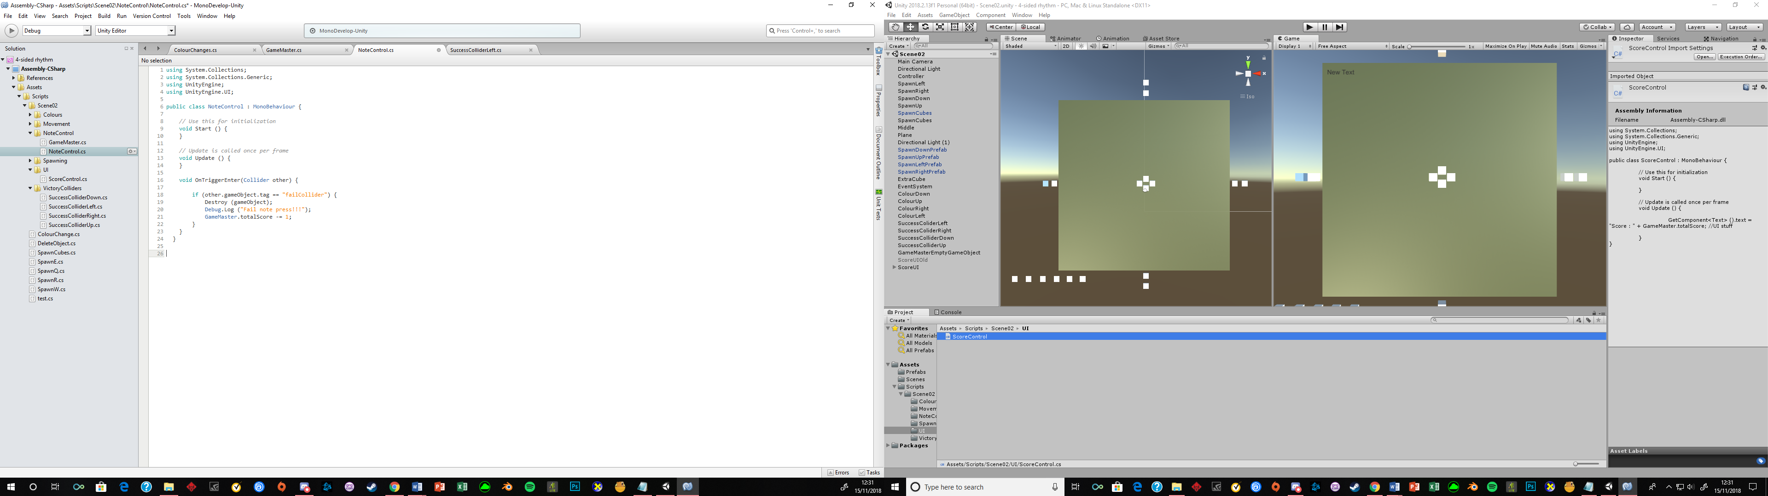

NoteControl script:

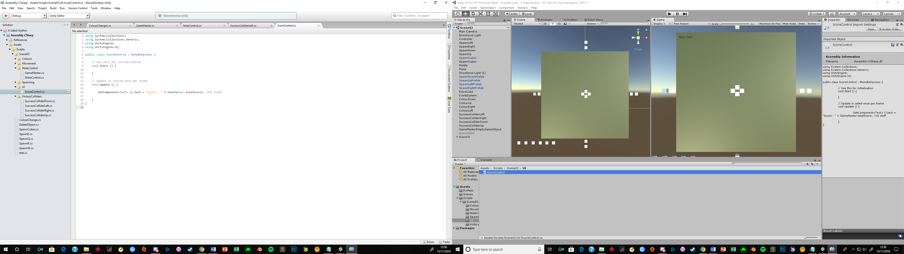

1. Attaching the scripts and components

Now after saving the script switch back to the Unity editor.

Attach the DeletingObject script to the failCollider, attach the GameMaster script (UI) to the empty GameObject & attach the NoteControl script to the drop cube. Run the scene the drop cube should fall and get deleted after reaching the failCollider & should display a minus score in the UI.